**COMP 1210**

**Fundamentals of Computing I**

**Fall 2016**

Dr. J. Cross

Computer Science and Software Engineering Auburn University

**http://www.eng.auburn.edu/~cross/comp1210**

# Course Overview

1. Syllabus (http://www.eng.auburn.edu/~cross/comp1210/)
2. Introduction
3. Data and Expressions
4. Using Classes and Objects
5. Writing Classes
6. Conditionals and Loops
7. More on Conditional and Loops

8. Arrays

7. Object-Oriented Design

1. Inheritance
2. Polymorphism
3. Exceptions

(2 through 10 above are in separate files.)

# Introduction

• Objectives - when we have completed this introduction to computing, you should be able to:

* Understand the basics of software and its relationship to hardware
* Write simple Java programs
* Edit, compile, and run Java programs using jGRASP
* Set a breakpoint and step through your program in debug mode
* Use Javadoc comments in your programs
* Run Checkstyle to verify your comments and format
* Generate documentation for your programs

# Background

* Computer System
  + Hardware and Software
* Hardware
  + “Physical” processor, memory, I/O devices, …
* Software
  + “Abstract” instructions and data stored electronically
  + Program instructions are human readable as text and machine readable as executable binary
* Computing
  + “The Act of” - Software running (executing) on hardware, processing input and producing output to solve a problem, entertain, communicate, etc.
* Fields/Disciplines of Computing
  + CS + SwE (incl WRSwE) + CpE + IS + IT + …

# Sw and Hw Relationship

* Bare Machine
  + All physical components, devices, microcode
* OS/Network Layer
  + All system software: OS, Network, device drivers

(Windows, Linux, Mac OS X, UNIX)

* + Management of all hardware: processor, memory, I/O devices
  + Management of all running software (multiple processes)
* Application Layer
  + All software applications: MS Office, Internet browsers, IDEs (Integrated Development Environments), compilers, …, including **programs written in COMP 1210**

# Sw and Hw Relationship

Bare Machine

OS/Nw Layer

Application Layer

# Software

* In COMP 1210
  + Hw is assumed; designed/implemented by CpE, EE, physicists, etc.
  + Sw is our focus; designed/implemented by CS, SwE, IS, etc.
* Developing Sw is about
  + Problem solving
  + Design, construction, testing, …
  + Managing the inherent complexity
  + Organizing the algorithms (instructions) and data as classes and objects in object-oriented programming

# Object-Oriented Concepts

* Classes
* Objects
* Encapsulation
* Inheritance
* Polymorphism
* Exception Handling

All of these OO concepts are directly supported in the Java programming language

# Java

* A *programming language* specifies the words and symbols that we can use to write a program
  + Employs a set of rules *(syntax)* that dictate how the words and symbols can be put together to form valid *program statements*
  + Defines the meaning (semantics) of *program statements*
* Java was created by Sun Microsystems and introduced in 1995 (acquired by Oracle, 2010)
* Java continues to evolve and grow in importance to the software industry

# Java Program Structure

* In the Java programming language:
  + A ***program*** is made up of one or more *classes*
  + A ***class*** contains zero or more data and/or *methods*
  + A ***method*** contains zero or more local data and/or program *statements* that form an *algorithm*
* These terms will be explored in detail throughout the course
* A Java application has a class containing a method called **main**

# First Program with jGRASP

1. Start up jGRASP
2. Open a new file
3. Enter the program (incrementally: steps 3-6) - The program should print “War Eagle” three times
4. Save program
5. Compile program
6. Run program (check for correct output)
7. Set a breakpoint and Debug (step through each statement
8. Generate the control structure diagram (CSD) and Documentation; turn on/off line numbers

# jGRASP

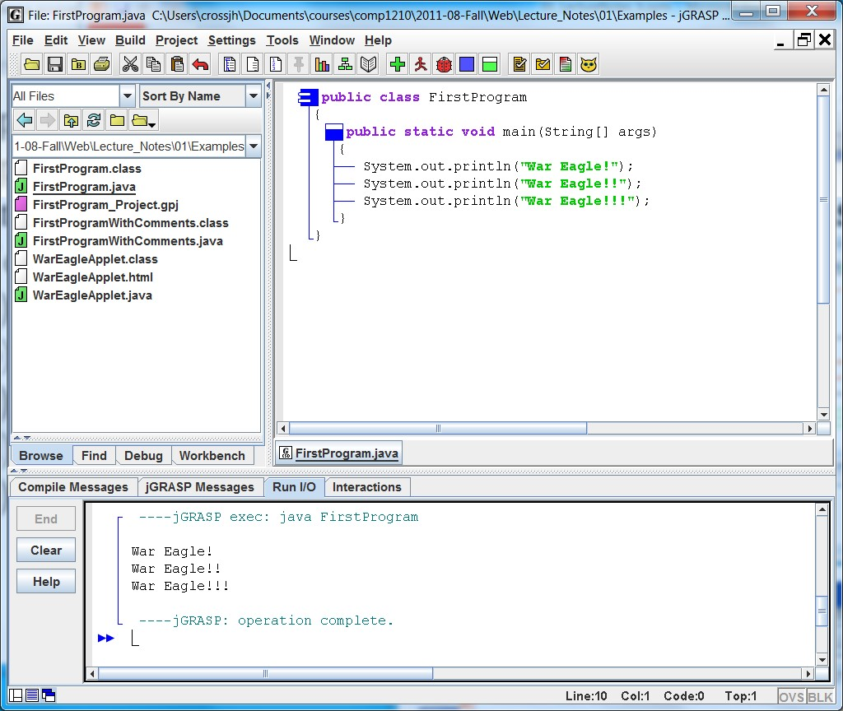

FirstProgram.java

# jGRASP

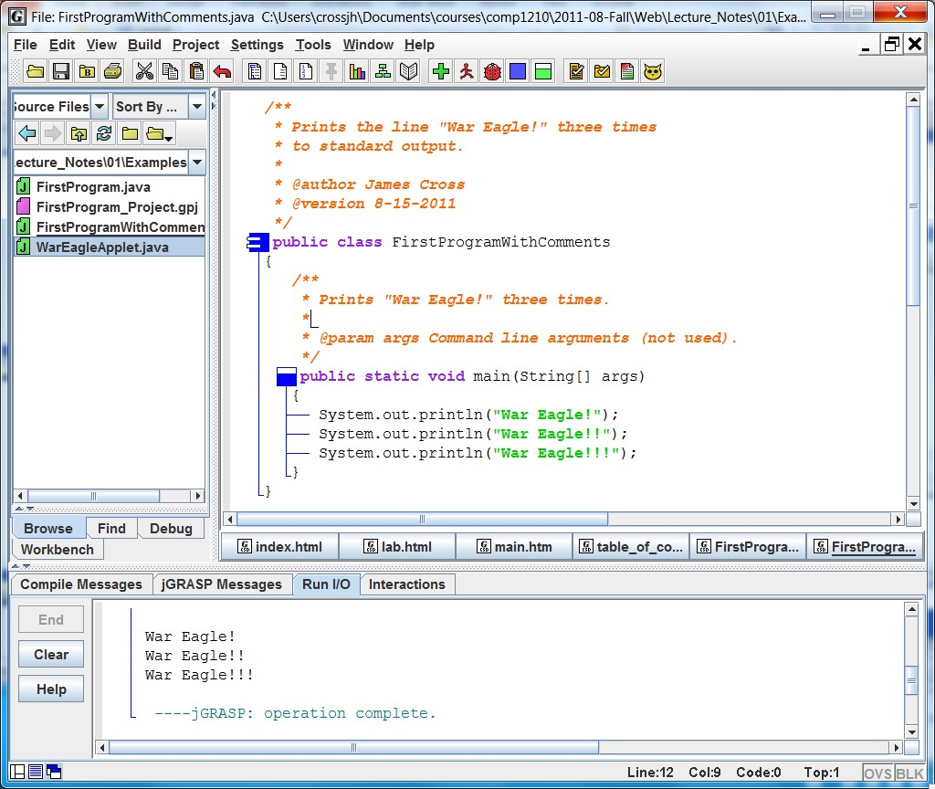

FirstProgramWithComments.java

# Software Concepts

Algorithms and Data

Dissecting a Java Program

Program Development, Translation, and Execution

Syntax, Semantics, and Errors

Overview of Programming Languages

Object-Oriented Programming Applets vs. Applications

# Algorithms and Data

* Sw ::= algorithms (“instructions”) and data
* Algorithms ::= Sequence, Selection, Iteration of instructions
* Pseudo-code (initial prog. design) becomes “formal” program (i.e., code in a programming language like Java)

▪ Pseudo-code can become comments in the program

* Many pieces of code for algorithms and data
* Organized into classes which define objects (Object-Oriented Programming)

# Dissecting a Java Program

**/\*\***

* **Prints the line "War Eagle!" three times* to standard output.**

**\***

* **@author James Cross* @version 08-16-2013**

**\*/ public class** FirstProgram

{

**/\*\***

* **Prints "War Eagle!" three times.**

**\***

* **@param args Command line arguments (not used).**

**\*/ public static void** main(String[] args) {

System.out.println(**"War Eagle!"**);

System.out.println(**"War Eagle!!"**);

System.out.println(**"War Eagle!!!"**);

}

}

# Parts of this Program

|  |  |
| --- | --- |
| * Comments * Class * **main** Method * Identifiers   ▪ Reserved Words | **/\*\***   * **Prints the line "War Eagle!" three times* to standard output.**   **\***   * **@author James Cross** * **@version 08-16-2013**   **\*/ public class** FirstProgram |

{

▪ Other (e.g., method and **/\*\***

|  |  |  |
| --- | --- | --- |
| variable names)   * Java API * Literals – actual values * White space   **Identifiers** can be any combination of letters, digits, dollar sign ($) and underscore | } | * **Prints "War Eagle!" three times.**   **\***   * **@param args Command line arguments (not used).**   **\*/ public static void** main(String[] args)  {  System.out.println(**"War Eagle!"**);  System.out.println(**"War Eagle!!"**);  System.out.println(**"War Eagle!!!"**); } |
| (_) characters; cannot begin with a digit. Java is “case sensitive”. |  | **Q1 Q2 Q3** |

## Program Development

* There’s more to developing software than coding (a.k.a. construction or implementation)

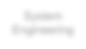

System

Engineering



Requirements

Analysis



Design



Construction



Testing



Maintenance

**Our focus in**

**COMP 1210**

* Many variants of the process model

## Program Development (cont.)

* Code
  + Writing source code that will be compiled into a program.
  + **Coding standard**: Rules as to how source code should be formatted - makes code easier to read and debug.
* Test (Unit Test)
  + Once you write your program, make sure that the **actual output** of your program (your programs output) matches the **expected output** (the correct output as specified by the customer).

“Construction” – may refer to Code and Unit Test

## Program Development (cont.)

• Program development tools are valuable aids during the process.

* A good IDE (integrated development environment) with program editor, debugger, interactions, etc.

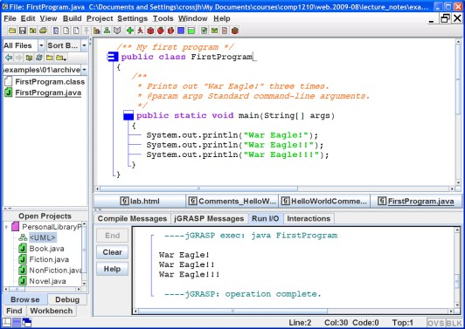will should become one of your best sw tools.

* *jGRASP* (jgrasp.org) with

Java, Checkstyle, JUnit,

Web-CAT

* *Checkstyle* is used with jGRASP to support the COMP 1210 coding standard.

## Program Translation

* **Compiler** v. **Interpreter (Java Virtual Machine)**
* The Java translation process:

**Java**

**source code**

(

.java files

)

**Java**

**Compiler**

javac

)

(

**Bytecode**

(

.class file

)

**Java**

**Interpreter**

JVM, JRE (java)

Bytecode

**Compiler**

Machine

code

**Fast**

**Faster**

**–**

**but rarely used**

**in practice (not used in**

**COMP 1210)**

**The Implementation Cycle...**

*Debug*

Edit

Compile

Run



* This cycle implies incremental program construction.
* Plan to repeat this cycle early and often.

## Syntax and Semantics

* Syntax: “grammar”
  + Rules of how the vocabulary can be used to compose legal structures in the language.
  + In the context of programs, the language syntax describes how to form legal statements and other constructs in the language.
* Semantics: “meaning”
  + What a given legal structure in the language means.
  + In the context of programs, the language semantics describes what will happen when a legal statement in the language is executed.

## Syntax and Semantics (cont.)

* In natural languages, some things can be syntactically correct but have no meaning… ▪ Blue ideas sleep furiously.
* … or be syntactically correct but have many (possible) meanings.
  + Time flies like an arrow.
  + The house flies like a saucer.
  + Did you ever see a home run?
* Programming languages do not allow these situations - - there is no ambiguity!
  + A program will have the same behavior each time it is run - - assuming input, if any, is the same.

## Program Errors Q4 Q5 Q6

* **Compile-time errors**

▪ Compilation cannot be completed

* Syntax errors
* Static semantic errors

▪ The Java compiler will not produce bytecode.

* **Logical errors (logic errors)** 
  + Execution proceeds and halts normally, but incorrect behavior or incorrect results are observed.
* **Run-time errors**
  + Execution is halted abnormally.
* Deep-end, crash, blow up, crash and burn, hosed ▪ Illegal operations, exceptions.
* Find errors by **testing** and remove them by **debugging**

## Overview of Programming Languages

* A programming language is an artificial language designed for humans to express programs and have these programs translated into machine-executable form.
* Programming languages can be categorized in different ways, for example:
  + Machine languages
  + Assembly languages
  + **High-level languages (e.g., Java, C++, Python)**
* Languages in different categories are obviously going to be very different from each other, but even languages within the same category can vary widely.

## Same Program, Different Languages

|  |  |  |  |  |  |  |
| --- | --- | --- | --- | --- | --- | --- |
| |  | | --- | | ***Java***  **/** Prints a quote from the Plains */ public class War_Eagle**  **{ public static void main(String[] args)**  **{**  **System.out.println ("War Eagle!\n"); }**  **}** | | | | |  | | --- | | ***C***  **/* Prints a quote from the Plains */ main()**  **{ printf ("War Eagle!\n"); }** | | |
| |  | | --- | | ***Ada***  **-- Prints a quote from the Plains with Ada.Text_IO; use Ada.Text_IO; procedure War_Eagle is begin**  **Put ("War Eagle!"); New_Line; end War_Eagle;** | | |  | | --- | | ***Perl***  **# Prints a quote from the Plains print "War Eagle!”, “\n";** | | |

## Object-Oriented Programming

• OOP is a programming world-view in which things in the real world are modeled as software **objects**.

▪ An object is really just an **abstraction** of a realworld thing, implemented as an **encapsulation** of private **data** and **methods** (operations on that data).

a

b

c

d

e

f

g

h

i

## Object-Oriented Programming (cont.)

• Objects communicate by sending **messages** to each other.

j

k

l

m

n

o

p

q

r

a

b

c

d

e

f

g

h

i

s

t

u

v

w

x

y

z

## Object-Oriented Programming (cont.)

• **Class** = a description of an entire category or group of objects

▪ Classes model categories of real world things by describing their “data” and their “operations.”

Class Name: GamePlayer Data:

Level

Speed

Health points

**...**

**...**

Level

Speed Health points

...

Operations: Run

Jump

Pick up item

...

## Object-Oriented Programming (cont.)

• An object is an **instance** of some particular class.

Level :20

Speed: 45

Health points: 70

**...**

**...**

Level :50

Speed: 60

Health points: 100

**...**

**...**

**Player2**

**Player1**

## Object-Oriented Programming (cont.)

• New classes are derived from existing ones through **inheritance**.

**Employee**

**Staff**

**Faculty**

**StudentWorker**

**Advisor**

Suppose

you were

creating a

program to

track

employees

at Auburn

University...

## Object-Oriented Programming (cont.)

* OOP is intended to support software **reuse**.
* **Class libraries** are an important element of this support.
  + Class libraries are sets of classes designed to be reusable components whose services can be used by many programs.
* The Java Application Programming Interface (**API**) is a set of class libraries that comes with the **JDK**.
  + The Java API is organized into **packages** such as **java.awt**, **java.io**, **java.lang**, and **java.net**
  + Example: The System class that you use in your output statements is in the java.lang package